**How to deploy WordPress into Linux App Service using Marketplace Template**

## **Create the App Service**

1. Click the following link to begin the process of creating the APP service in your tenant. This will bring you to the **WordPress on Linux > Create** page. <https://ms.portal.azure.com/#create/WordPress.WordPressonlinux>
2. Create an **APP Name**. Select **Use Existing** or C**reate New** resource group. Click the **App Service plan/Location** blade to specify the App Service Plan. Click the **Create New** button.
3. In the **New App Service Plan** window enter a name for the service plan, enter the desired location, and pricing tier.

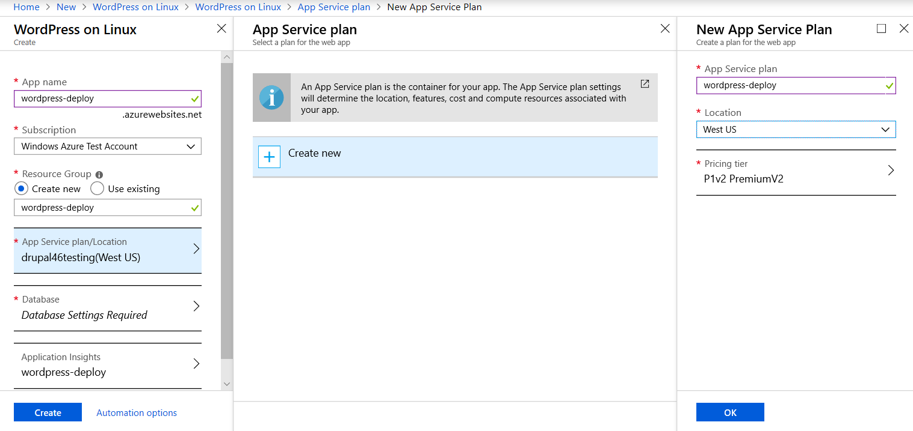

1. Click the **Database** blade.
2. Enter the desired settings for your MySQL instance. Then click **OK.**

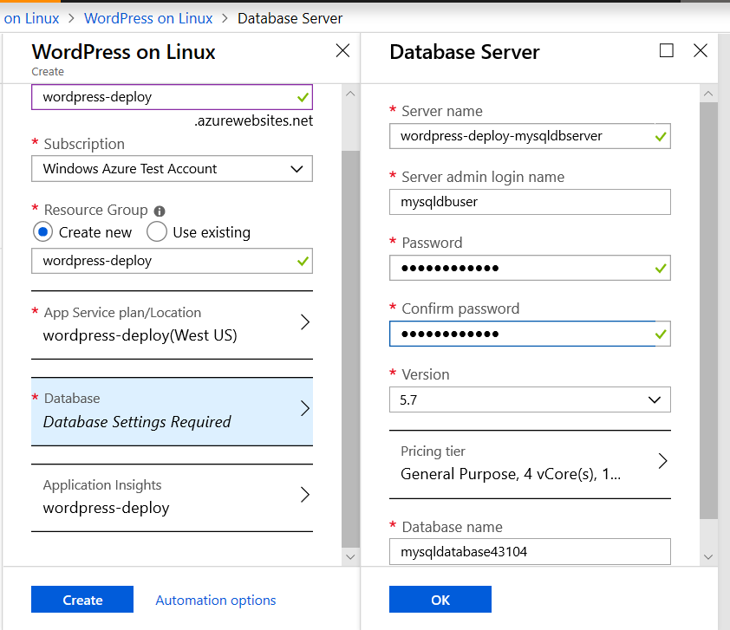

1. Click **Create.**

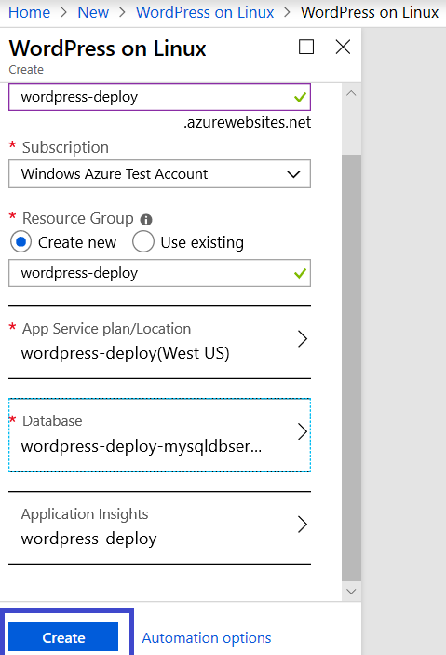

1. Once the deployment completes, you will see a “**Deployment succeeded**” message in the notification’s menu.

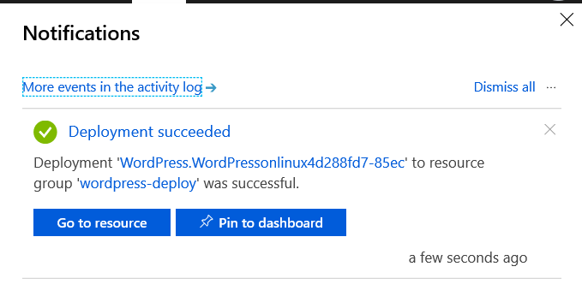

1. Click the **Go to resource** button. This brings you to the **App Service Overview**.

1. From here click the **URL** link to navigate to your site. You should see a page like the one below.

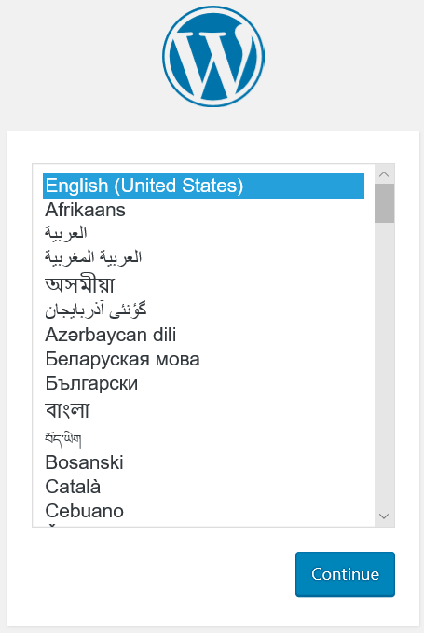

1. Click **Continue** to begin the initial WordPress install.
   1. Note: These are the standard steps for installing WordPress. For more in-depth information consult WordPress documentation. [Installing WordPress](https://codex.wordpress.org/Installing_WordPress).

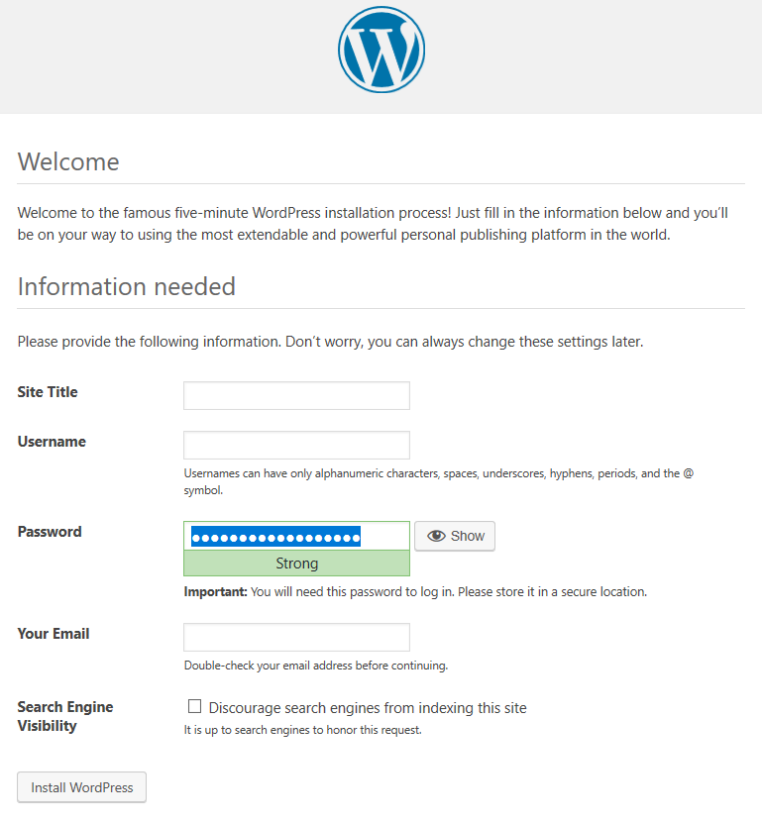

1. On the Installation page enter the required information. Make note of the password. Then click **Install WordPress.**
2. You should see a success page.

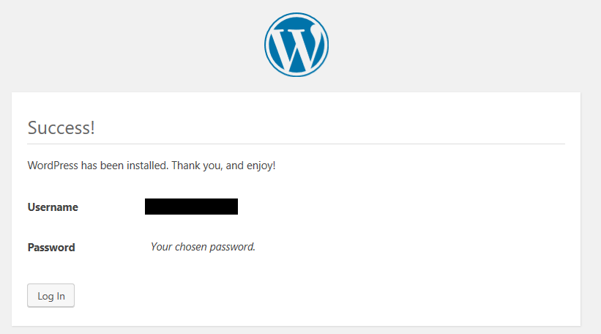

1. Click the **Log In** button.
2. This brings you to the administration page login.
   1. Note For future use this page can be accessed with http://[WebApp URL]//wp-login.php

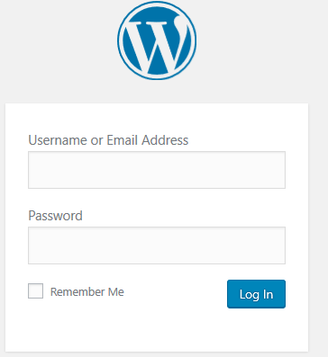

1. Enter the credentials you created. Then click **Log In.**

1. You are now logged in.

********************************************************